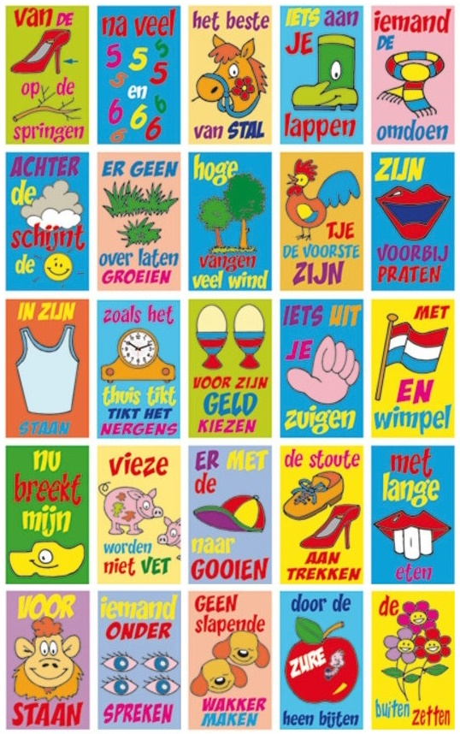

Welke spreekwoorden staan er getekend?
Noteer ze alle 25!

Eerste rij: 01 vul in
02 vul in
03 vul in
04 vul in
05 vul in

Tweede rij: 06 vul in
07 vul in
08 vul in
09 vul in
10 vul in

Derde rij: 11 vul in
12 vul in
13 vul in
14 vul in
15 vul in

Vierde rij: 16 vul in
17 vul in
18 vul in
19 vul in
20 vul in

Vijfde rij: 21 vul in
22 vul in
23 vul in
24 vul in
25 vul in

Vul de betekenis van deze spreekwoorden in!
Weet je het niet of twijfel je? Zoek het dan op internet!

01 vul in
02 vul in
03 vul in
04 vul in
05 vul in

06 vul in
07 vul in
08 vul in
09 vul in
10 vul in

11 vul in
12 vul in
13 vul in
14 vul in
15 vul in

16 vul in
17 vul in
18 vul in
19 vul in
20 vul in

21 vul in
22 vul in
23 vul in
24 vul in
25 vul in

