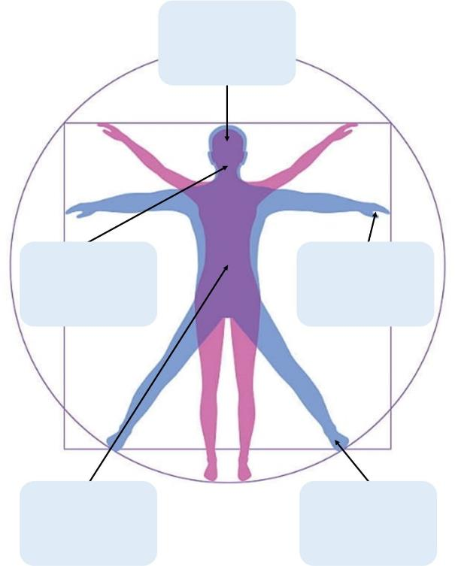

VUL IN

VUL IN

VUL IN

VUL IN

VUL IN