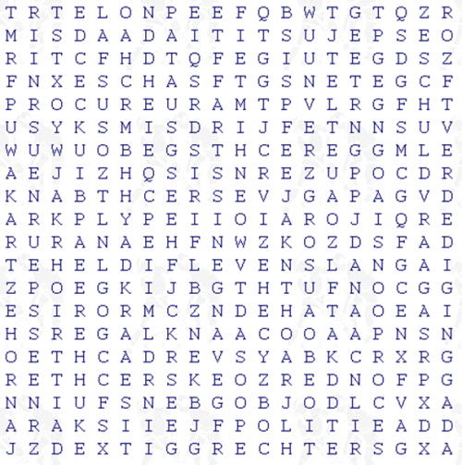

In deze woordzoeker zitten 27 woorden die te maken hebben met de rechtbank.

Noteer ze!

|  |  |  |
| --- | --- | --- |
|  |  |  |
|  |  |  |
|  |  |  |
|  |  |  |
|  |  |  |
|  |  |  |
|  |  |  |
|  |  |  |
|  |  |  |